CLASS DIAGRAM OF THE GIVEN PROBLEM:

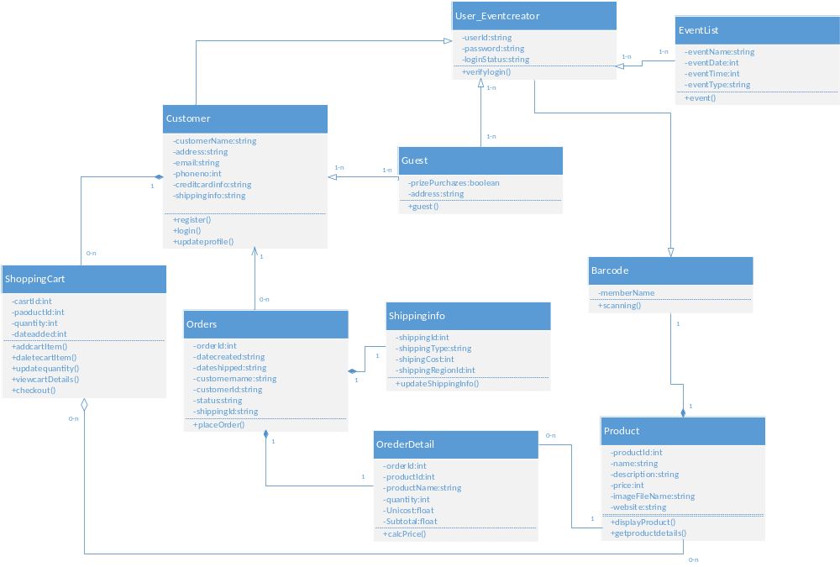

ARCHITECTURE DIAGRAM OF GIVEN PROBLEM:
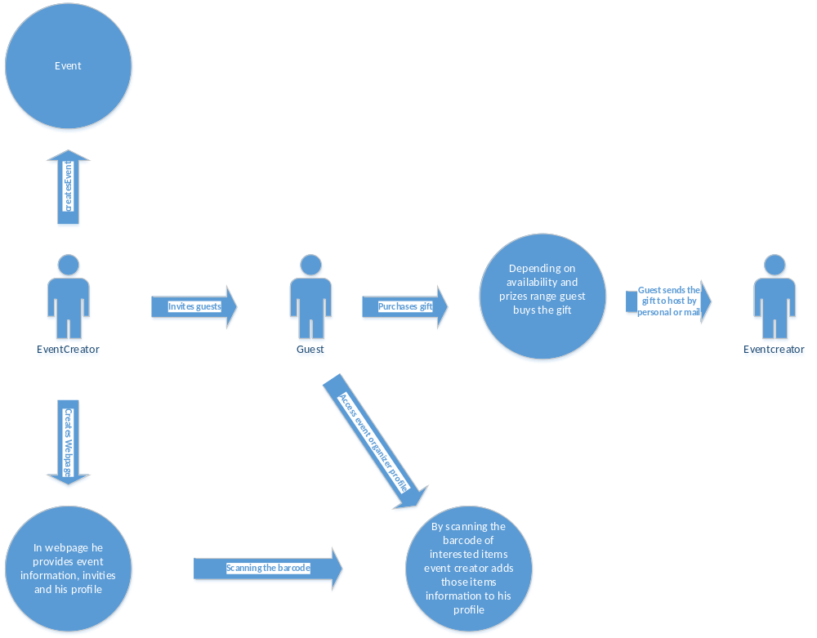

WEB PAGE CREATION IN .NET ENVIRONMENT:
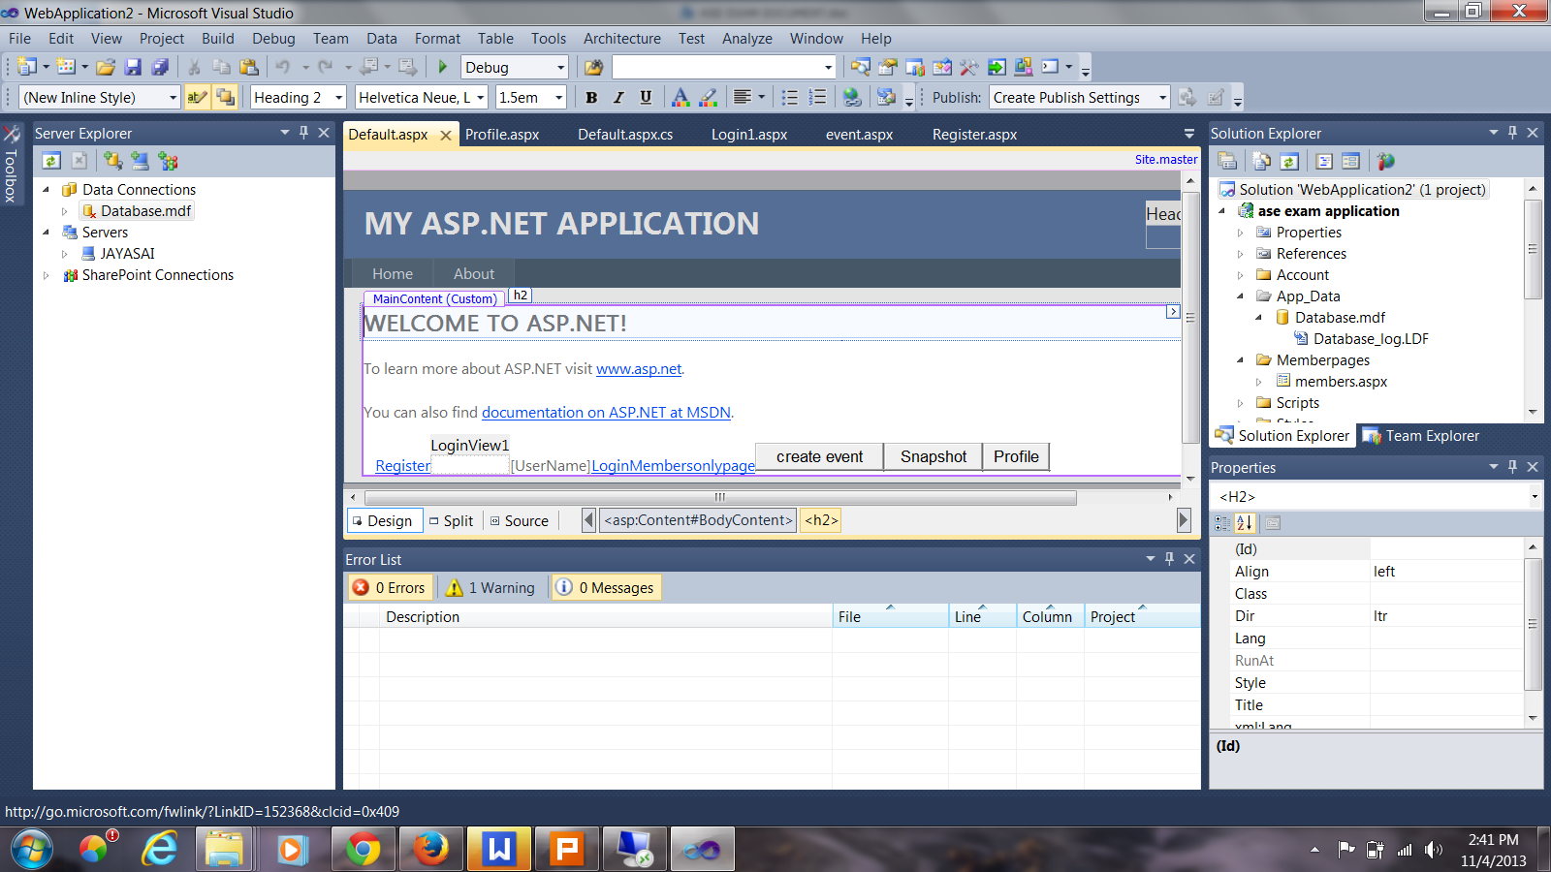
HOME PAGE OF THE APPLICATION:
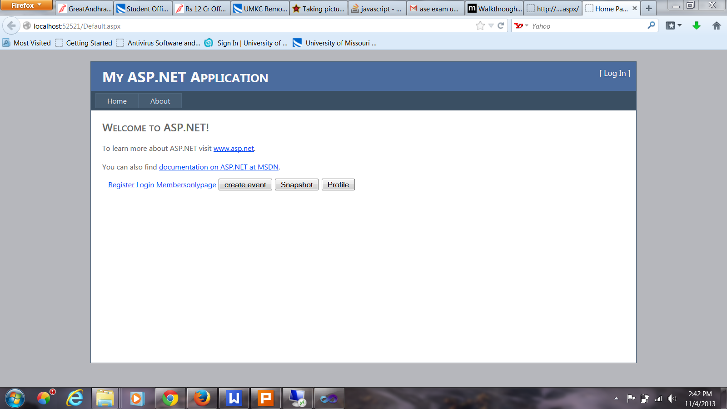

REGISTER PAGE:

COMPLITION SUCCESS MESSAGE AFTER COMPLITION OF REGISTER:


LOGIN PAGE:
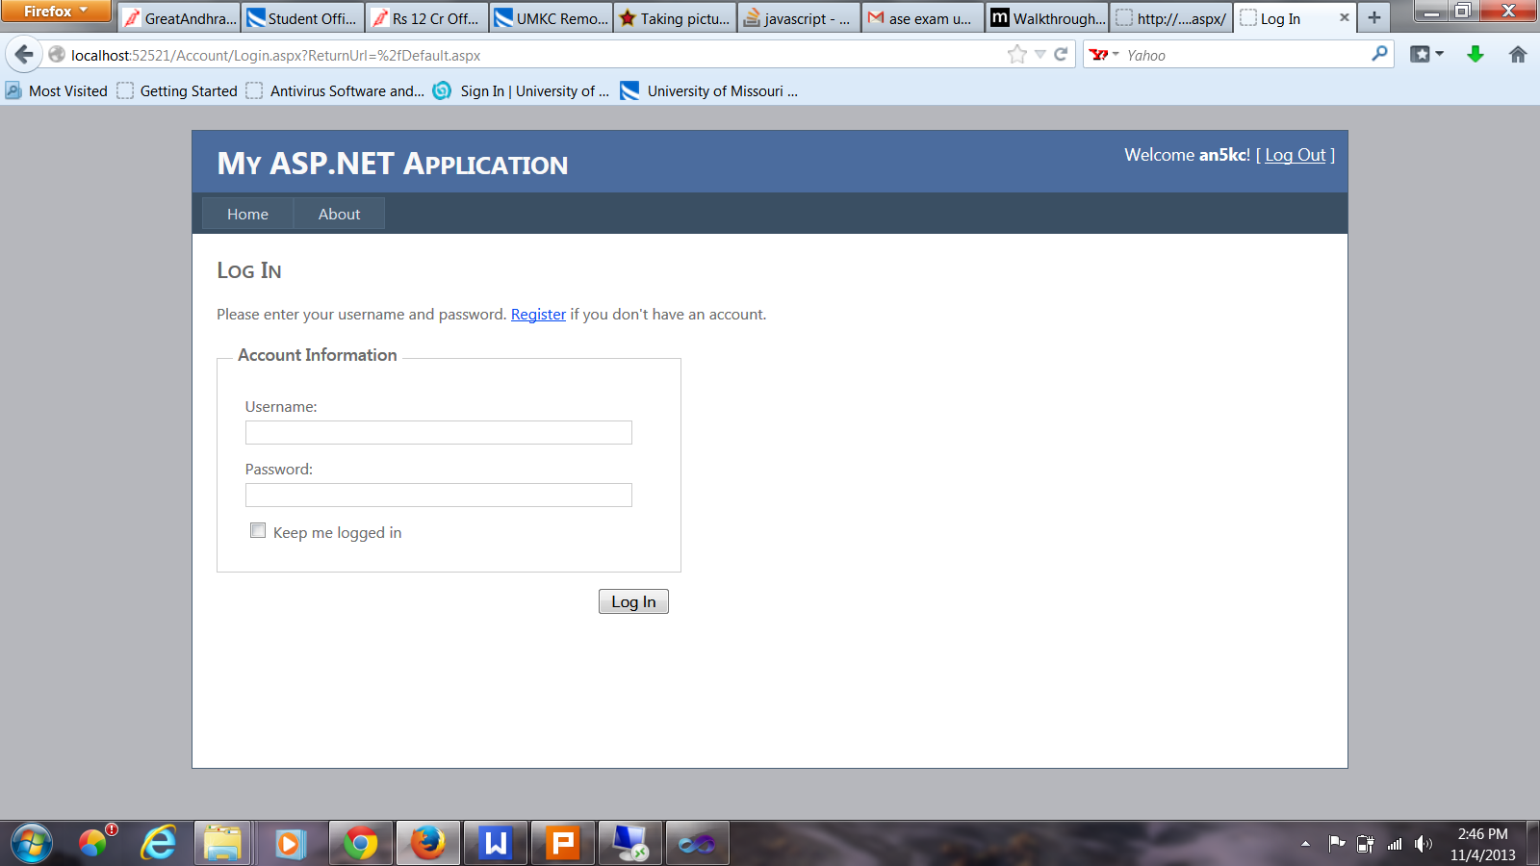
VALIDATION IS PROVIDED FOR LOGIN PAGE:
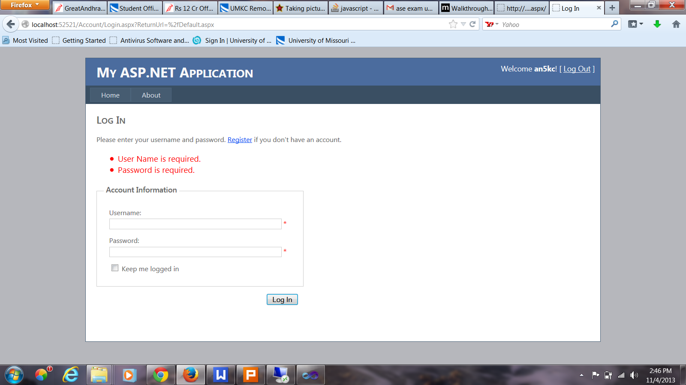

WEB PAGE OF THE USER AFTER LOGIN:
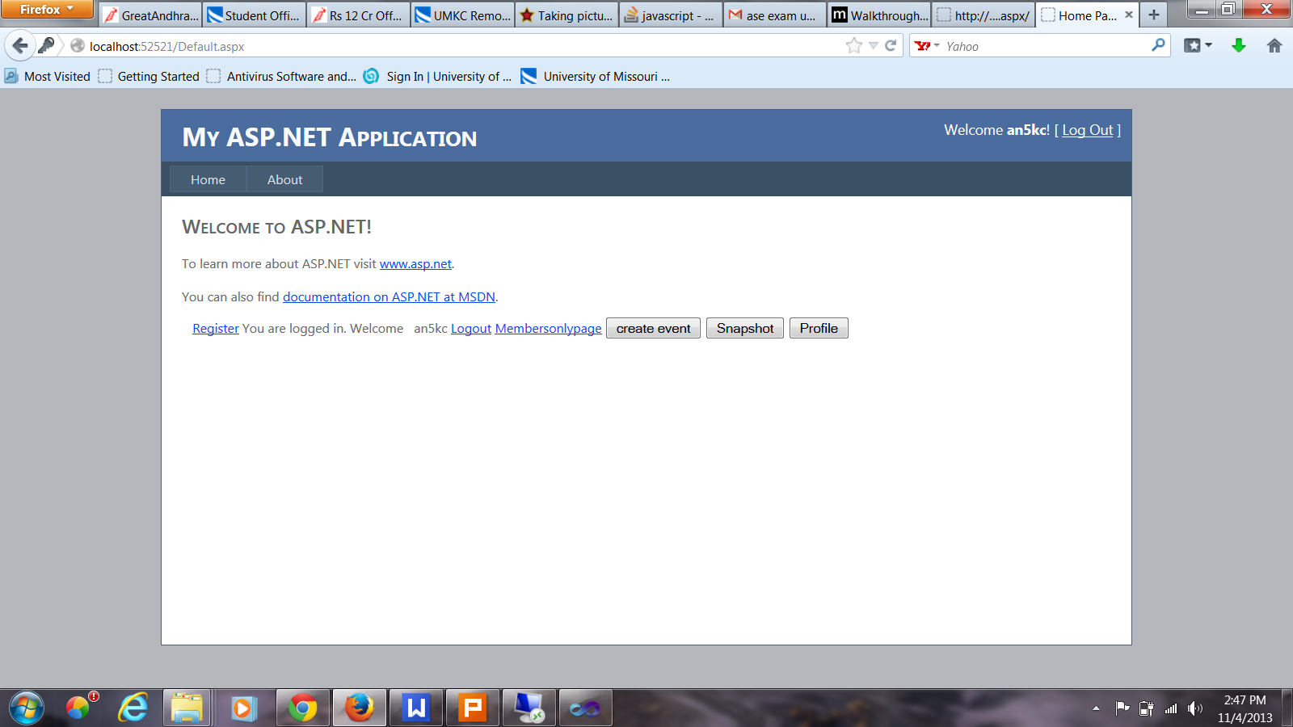
EVENT CREATION PAGE OF THE USER:


PROVIDING INFORMATION FOR REQUIRED FIELDS IN EVENT CREATION PAGE:
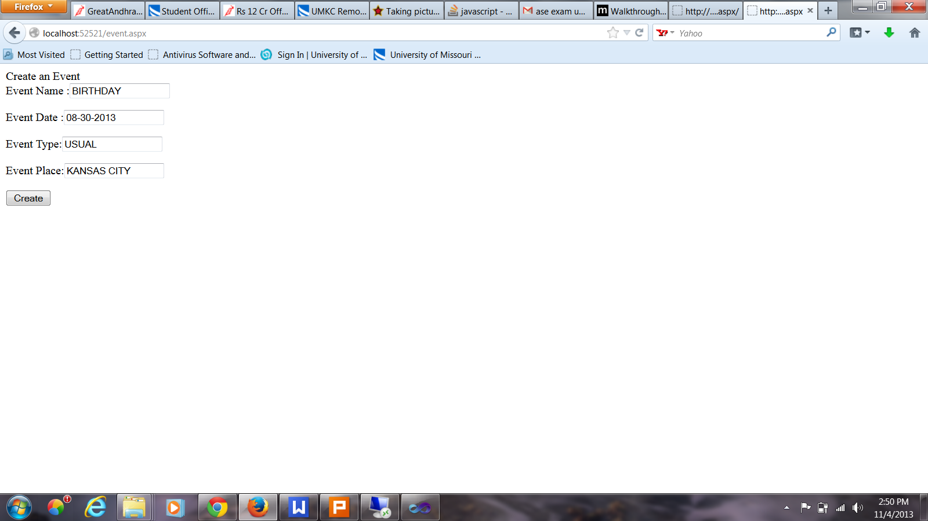
AFTER CREATING EVENT IT WILL GIVE CONFIRMATION MESSAGE THAT THE EVENT IS CREATED.
SNAP SHOT APPLICATION IS USED TO TAKE SNAP SHOT OF BARCODE OF THE ITEMS.
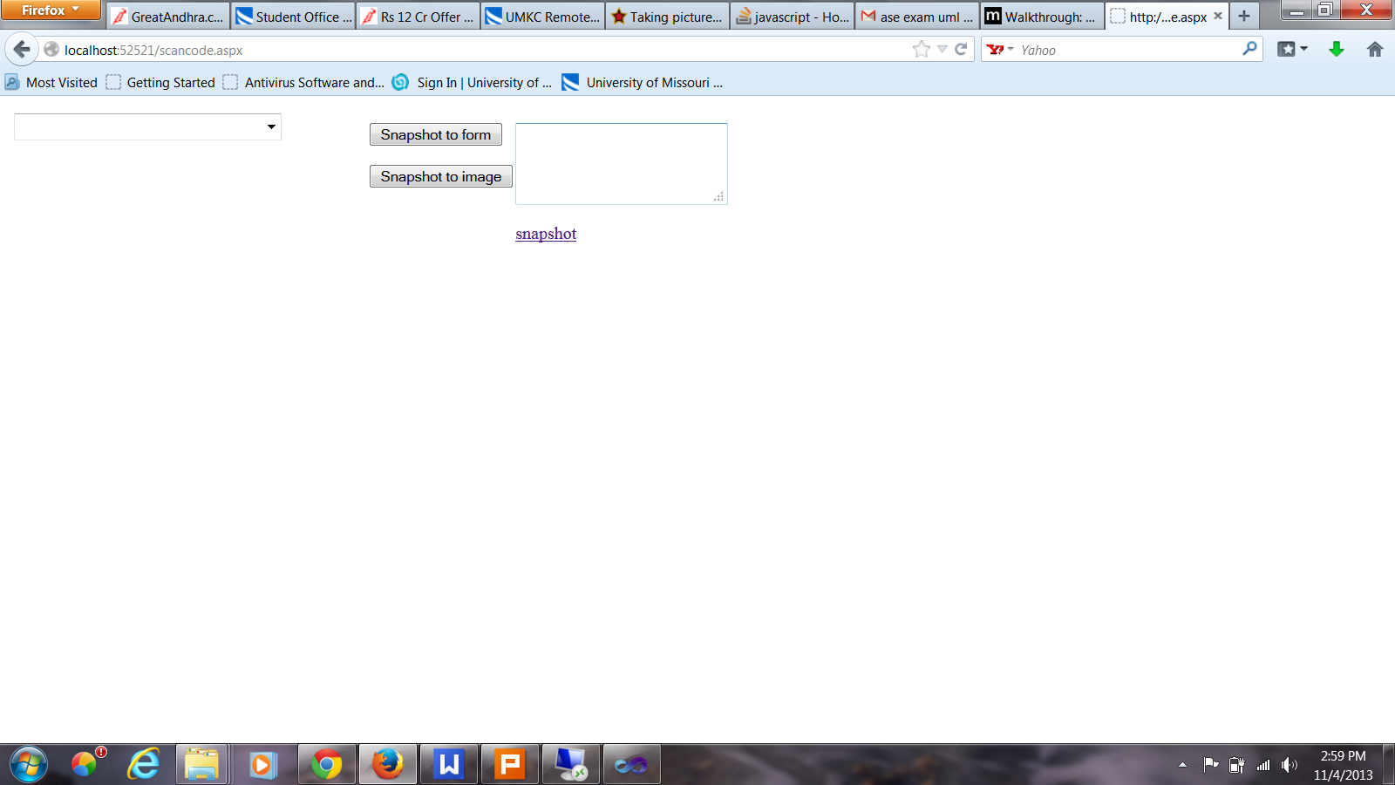

PROFILE PAGE OF LOGIN USERS:


PROVIDING INFORMATION FOR REQUIRED FIELDS IN PROFILE PAGE:
This profile page consists of user’s name, profession, address, hobbies, friends list, interesting items etc. Which are very useful fields in our problem solving.


After updating the information it gives confirmation message.
After clicking on logout it user redirect to the home page of the application.
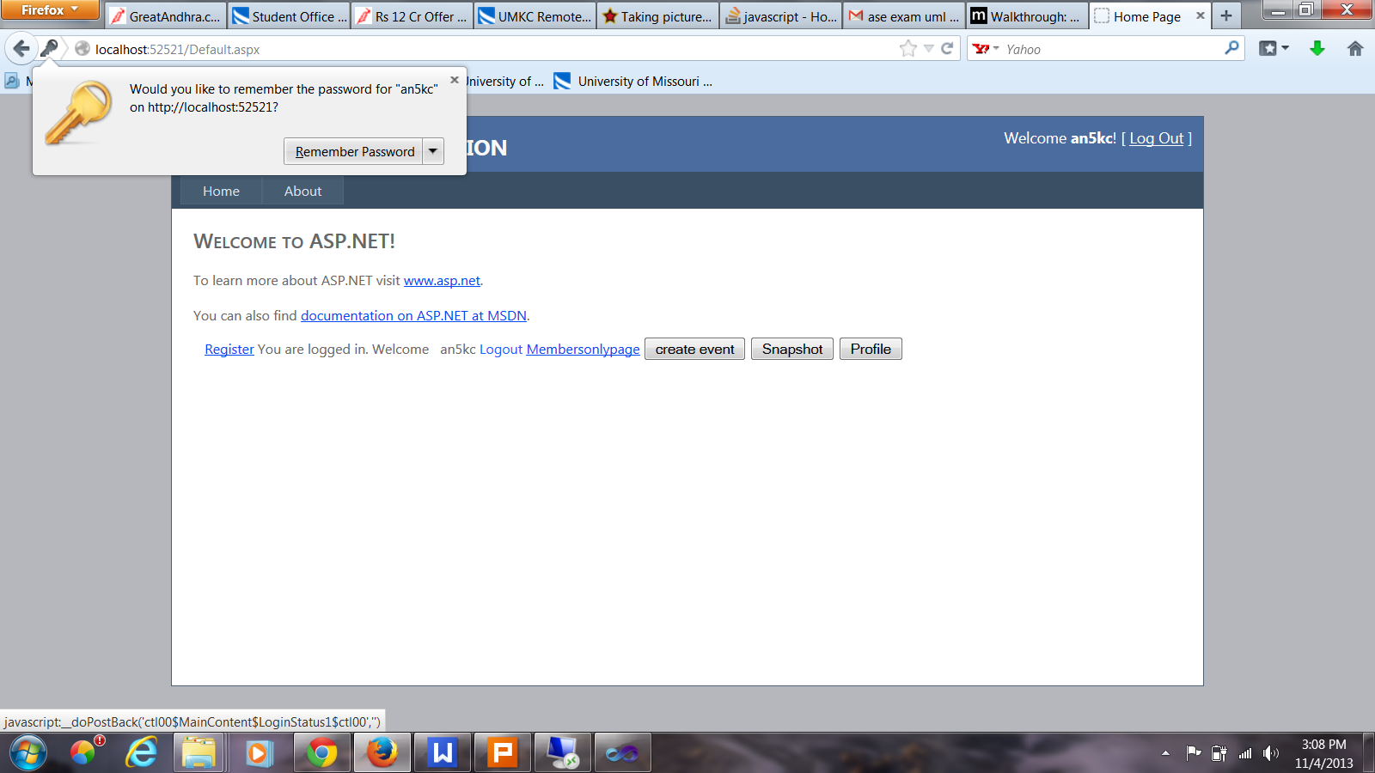

The below screen shot shows the database creation for the web application:
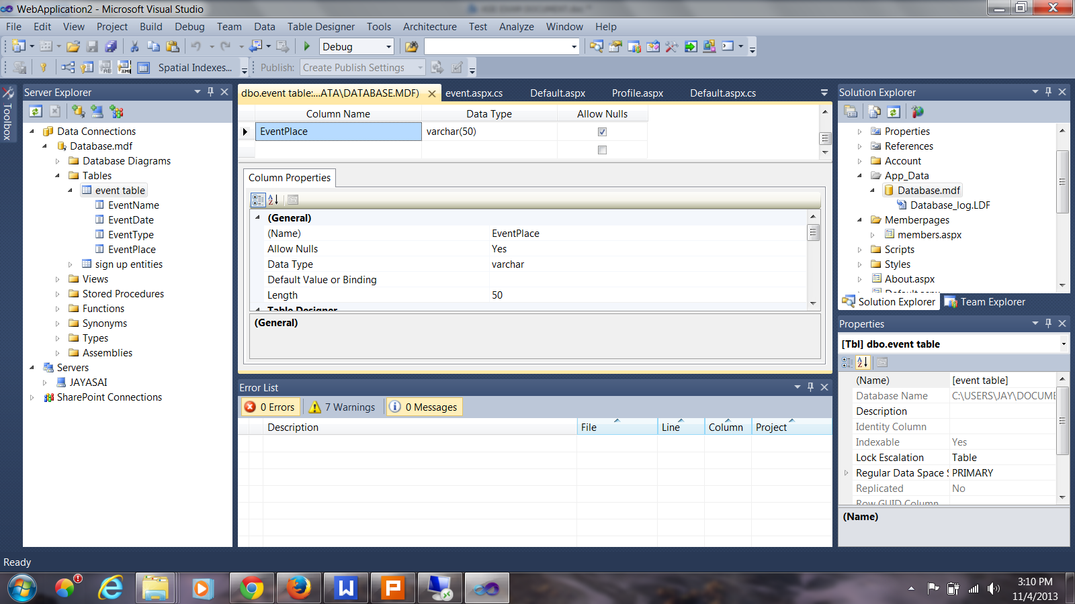

Mobile web application creation:
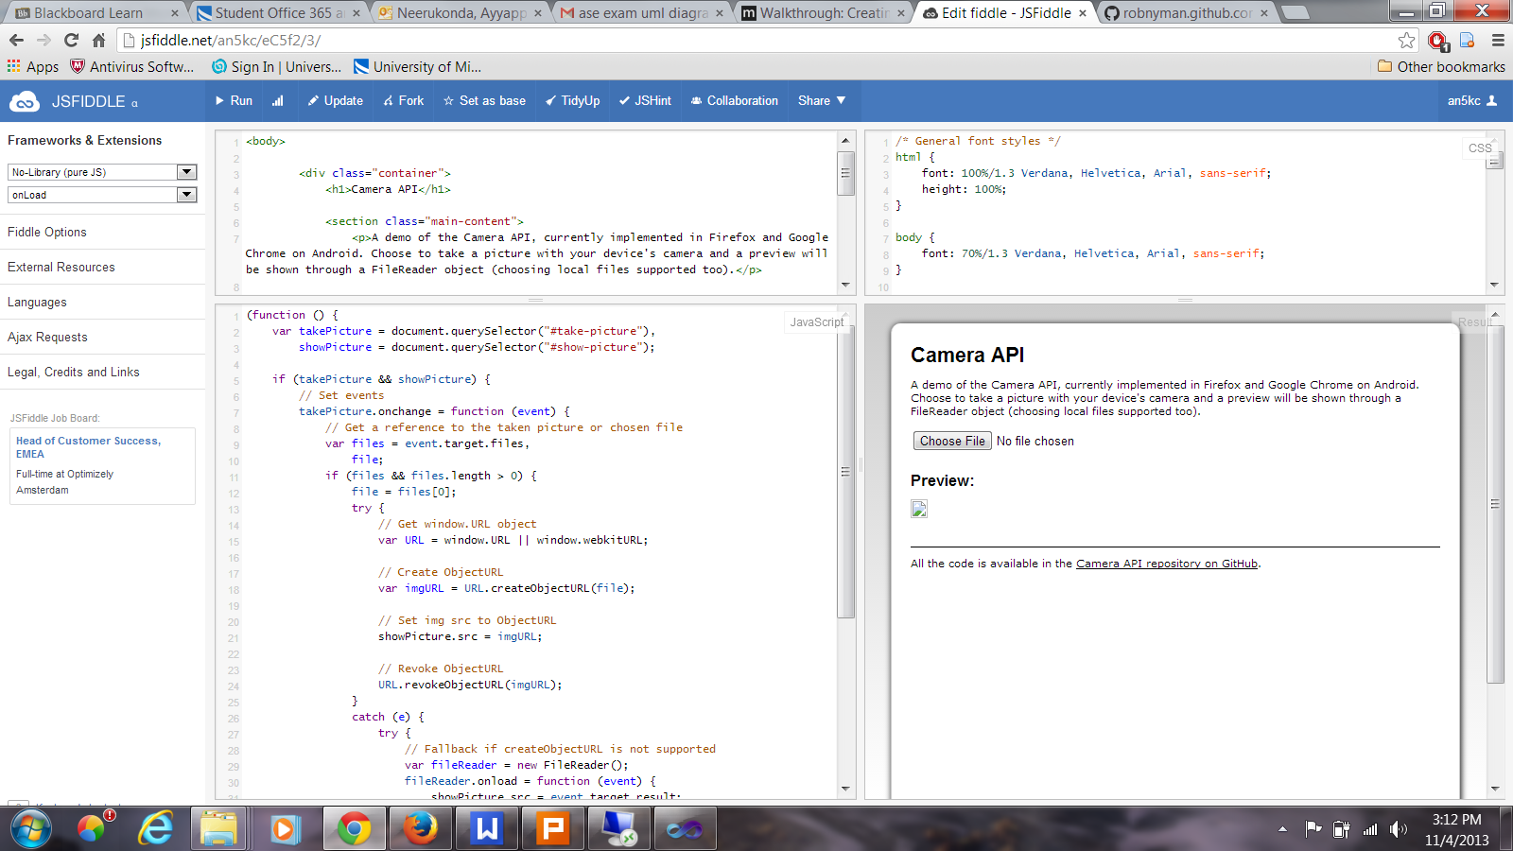
Here we have to choose the .jpg files which consists of the image of the Barcode.
Deploying into cloud:
